**Clitheroe Church Wins Gold Award**

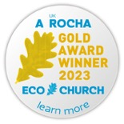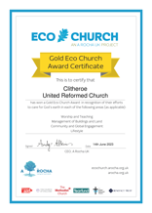Clitheroe United Reformed Church Elders are delighted to announce that they have been successful in achieving an Eco Church Gold Award. We are the 1st church in the Northwest URC Synod to achieve this Gold Award, the 35th Gold Awarded Eco Church in England and Wales, and 4th United Reformed Church in England to be awarded, so quite an achievement.

The EcoChurch award scheme is run by A Rocha UK, a charity who support Christians and churches in England and Wales to protect and restore the environment.

For more information about A Rocha UK <https://arocha.org.uk/> and EcoChurch  [ecochurch.arocha.org.uk](http://ecochurch.arocha.org.uk/)

Or to follow A Rocha UK on social media

Instagram: [@arocha_uk](https://www.instagram.com/arocha_uk)

Twitter: [@ARochaUK](https://twitter.com/ARochaUK)

Facebook: [@Arochaorguk](https://www.facebook.com/Arochaorguk)

Participating churches complete a free online survey to assess care for the world through their worship and teaching, care of buildings and land, how the church engages with their local community and in global campaigns and in the personal lifestyles of the congregation. Churches who might be successful in achieving Gold, based on survey results, receive an inspection visit.

The achievement of an EcoChurch Gold Award for Clitheroe URC has been a long journey since 2007, which predates any assessment or survey. It started with a wish to make the church more of a resource to the community, to become a ‘street level church’ as well as being more environmentally aware.

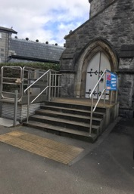Our church is situated on a main high street in Clitheroe a small market Fairtrade town in the Ribble Valley in Lancashire. The worship area is based at street level in the heart of Clitheroe not far from Clitheroe Castle entrance. Remodeling of the main entrance, with the addition of a lift, has allowed full disabled access. We do not fear change and we try to run our church in ways that take everyone's insight and contribution seriously.

Our building hosts a variety of clubs and activities for both the adults and children of our community and welcomes everyone to join us in our events and services. There is always work ongoing to make the church more ecofriendly and energy efficient. We are a Fairtrade church, which means we use and also promote fairly traded products such as teas, coffee, sugar, hand wash etc. We have also given our support to a toilet improvement initiative in Saleh Jath village in Sindh Province, Pakistan. One of our toilets is twinned to theirs.

There is always a balance to be struck to ensure Clitheroe URC can continue to offer a useful community resource, and doing this in a way that limits damage to the environment. This required a lot of changes to the church building to improve the layout and reduce our carbon footprint and energy usage, including installation of double and triple glazing, some of which is locally made stained glass by ‘Lightworks’.

Clitheroe URC has always been encouraged by our recently retired minister to consider the impact of our behaviour on the environment, locally and worldwide. This has been a central theme of worship and leadership of Clitheroe URC for a number of years. Stewardship of land and buildings in terms of this, and living by example are felt to be important aspects of our worship, land management and day to day living.

Our fundraising and grant applications have all been focused on improving the energy efficiency of our building and on access for the community and for community benefit. We have been awarded grants from Lancashire Environmental Fund.

Church members are involved in Clitheroe Fairtrade Town, The Shop of Hope CIC (Fairtrade, Ethical and community wellbeing recycled craft projects), Art4All community art for adults with special needs, DARE (Darwen Asylum and Refugee Enterprise), English Club providing free lessons to asylum seekers and refugees, Foodbank, Cookery Club for people needing Foodbank, and a counselling service under the Gateway Trust offered to anyone in Ribble Valley and surrounding areas.

A more recent development is the wildlife garden, developed during lockdown in 2020 from wasteland. This wildlife space helps to offset some of our carbon footprint as well as aiming to increase biodiversity. A part of this garden is also used by Tom’s Table as a kitchen garden to organically grow salads and herbs for his restaurant.

This area of land was previously neglected, full of rubbish and weeds and seemed to have limited prospects. However, we had been encouraged to apply for a silver Eco Church award, by our NW Synod Green Apostle and Missional Discipleship Mentor for Lancashire, (which we received in July 2020). As part of this submission, we considered our impact on the environment in terms of our building, land, worship and teaching, community engagement, and lifestyle. Consequently, the elders considered how we could use our land to develop a wildlife space.

Work began in 2020, tidying this neglected space, which was pretty overgrown with weeds. The aim was to develop a space that was environmentally friendly, and would encourage as much wildlife as possible. This initially required clearing building rubble, and weeds. Not all weeds were removed as some would help to encourage wildlife. For example, some nettles are kept throughout the year (but weeded to control), as they encourage butterflies in to the garden.

A bench to sit on was also made out of bricks and planks recycled from tidying the garden.

Other developments included making a bug hotel, bat-box, composting area, and pile of twigs/ logs to encourage insects and hedgehogs.

The gravelling and raised beds were created in summer 2022 by an outside contractor, thanks to two generous donations. Other members of the group and the congregation have donated plants and shrubs from their own gardens. A number of people from the group have helped with planting out. All the plants are attractive to wildlife.

During summer of 2022, perennials and shrubs were planted out from pots in to borders to make sure pollinators are available throughout the year. This included rehoming some Geraniums from the raised flower bed, so that this could be kept as a wildflower area.

The raised wildflower bed was seeded in September 2022, these flowers will hopefully seed in other places, and provide food for birds and insects.

Work was then completed in October 2022 to connect a water butt to our drainpipes, with a bit of repair work which was also required. This means we can use rain water to water the garden when required.

We were kindly donated a compost bin in December 2022. This helps to provide compost for potting and planting and allows for recycling of any compostable items from 1st Saturday events or teabags from tea and coffee after church.

Two bird feeders were added to the garden in 2022 for feeding them throughout the winter.

In 2023 additional bird nest pockets, and butterfly box were also added, along with a sunken bin lid to provide a water space for wildlife.

We also have an area of land at the front of the church that is on a busy main high street in Clitheroe with a bench together with small lawn and flower planters which are kept up to date seasonally to either side of the bench. This is regularly used by members of the public and for regular country markets. This is next to a managed parking area at the front of church which is used by a local disabled driver.

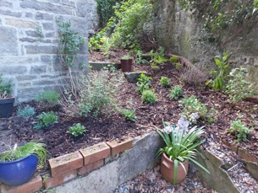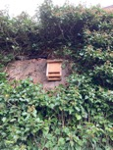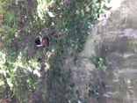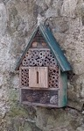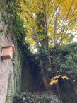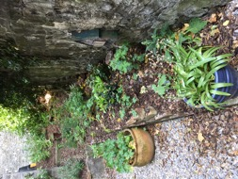

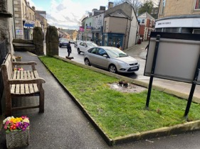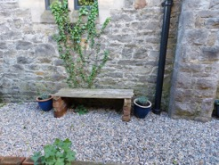

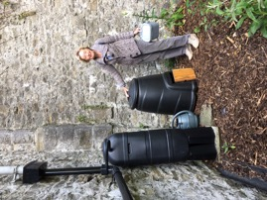

On a day to day basis simple changes made were use of cleaning products which are environmentally friendly, selling locally produced organic food and/or Fairtrade goods for events, and being careful about recycling waste including composting of items. A number of individuals offset carbon by using Ecosia as their search engine / internet browser. Ecosia plants a tree for every 45 searches and give regular updates on where and why these trees have been planted. This followed a service two years ago which included small group work on calculating our own individual carbon footprints.

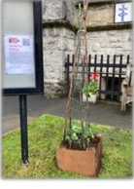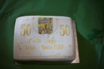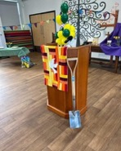Caring for creation and considering our impact on nature and the planet features regularly in prayer and worship. Equally important to us is the work with the community, involvement of junior church and more recently Barrow URC School (the only voluntary controlled URC school). This has included planting of 50 trees in 2022, and more recently Pigeon Peas, (a vegetable that can tolerate drought) at school and our church, as part of a service during Christian Aid week in May 2023. Both junior church and Barrow URC school pupils helped to complete ‘Count on Nature’ in June 2023.

The church constantly considers stewardship of our land and buildings, wider local and global environment, and how we aim to live our lives to take care of our planet and everyone / everything that lives on it. Not an easy task and nobody is perfect but we believe small changes do, and will continue to have a big impact.

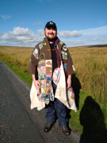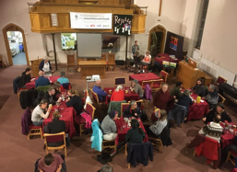During October 2021 we hosted COP26 pilgrims at our church and had environmentalist speakers at COP26 event also. Our church signed a letter encouraging our local MP to take climate change seriously and develop a climate change action plan.

One of our members is on the  organising group of the new Ribble Valley Climate Action Network. This has led to the church hosting a well attended Climate Conscious Hustings for the local elections, and to the  first "Citizens Summit for Climate and Nature" in the Ribble Valley, at Trinity Methodist Church in July 2023.

At the inspection visit on June 8th, Rose Gosling from A Rocha UK shared that her visit to Clitheroe URC “was very inspiring and that she enjoyed meeting a large and enthusiastic team, who had embedded environmental principles in everything that they do.”

Clitheroe EcoChurch group is made up of 10 people with additional members of the congregation also providing help when required. During our EcoChurch journey we have also appreciated the enthusiasm of our recently retired minister Rev Michele Jarmany, their NW Synod Green Apostle Rev Daleen ten Cate and Clitheroe URC congregation.

